Install docker in Linux(cloud) and Windows

1. Install in Linux(cloud)



Update, upgrade and install docker.

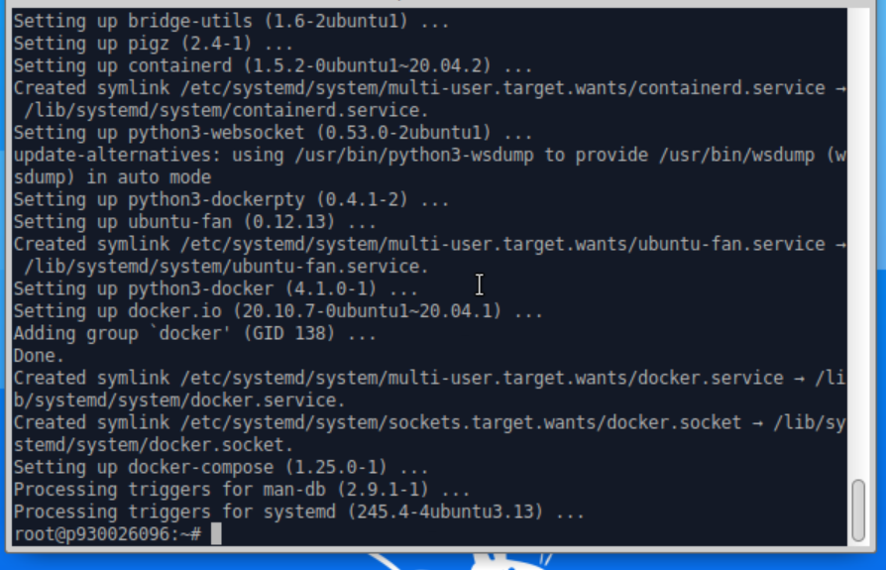

Successfully install docker.

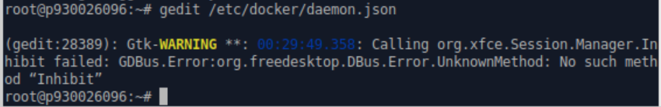

Edit .json file.

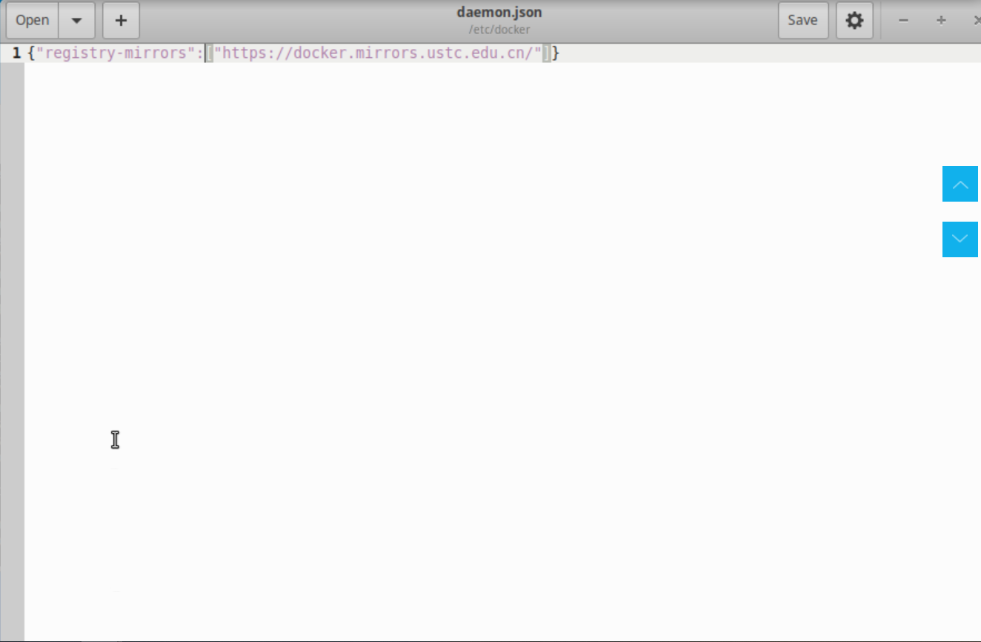

Edited content in .json file.

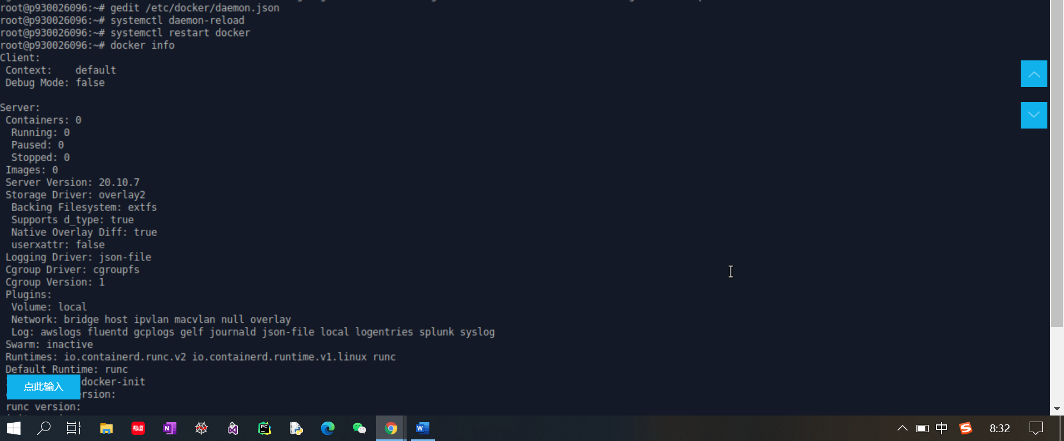

Check docker information, configuration done.

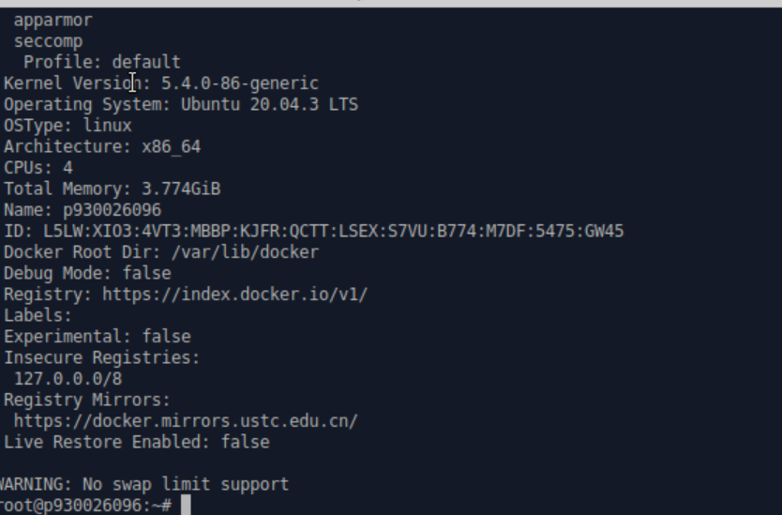

Check docker information, configuration done.

Install docker in Windows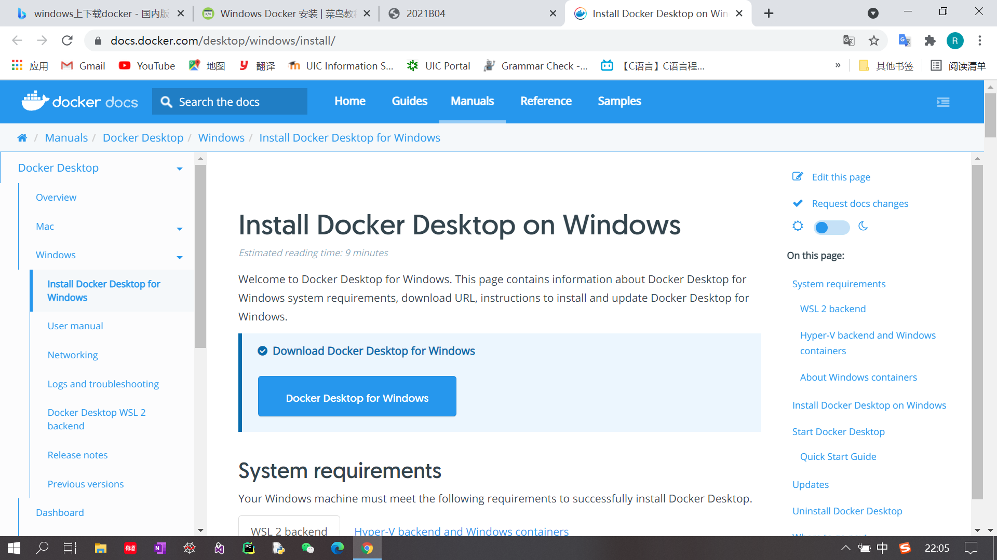

Go to the official platform to download docker.

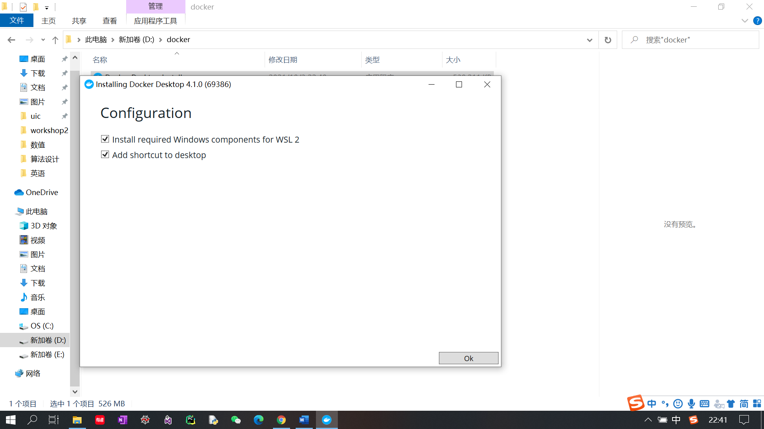

After download the install package, click ‘OK’. And wait.

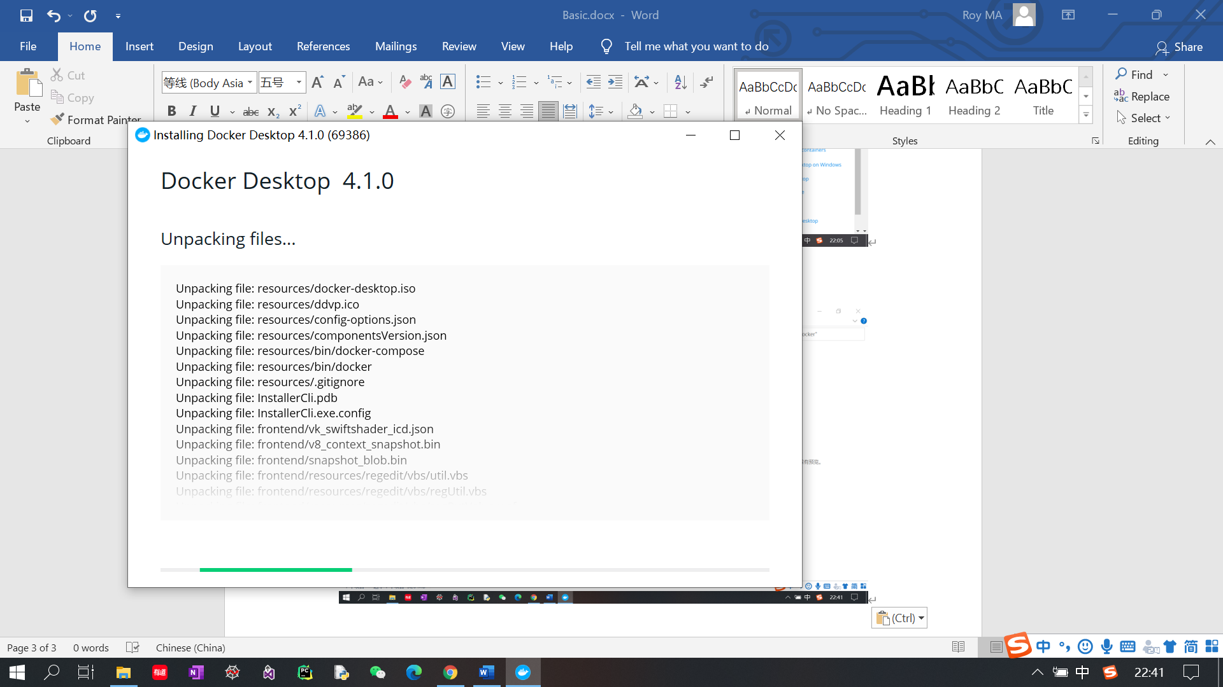

Wait for unpacking files. After finishing unpacking, computer would be restart automatically.

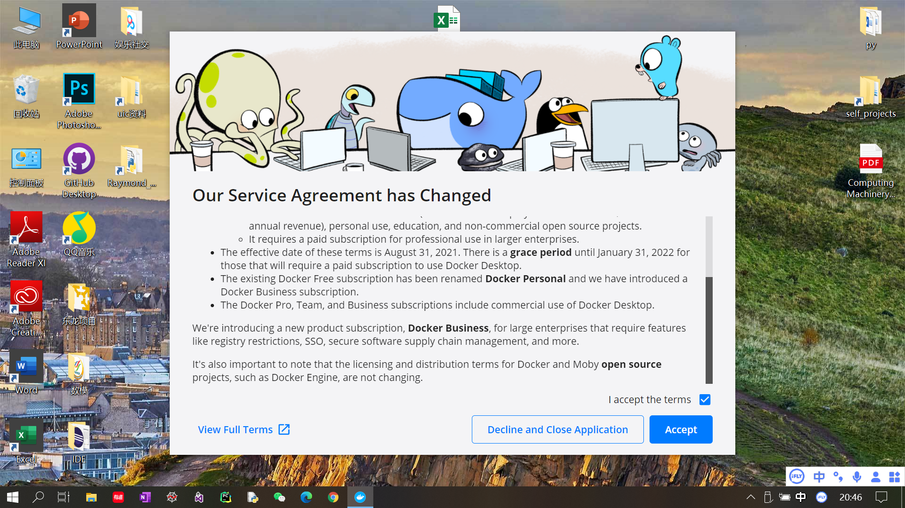

You will see such window after restart, click ‘accept’.

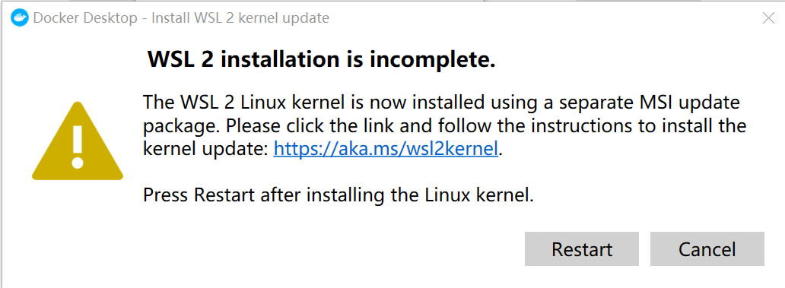

It would popup a warning window like this. Click the URL link to install the kernel update.

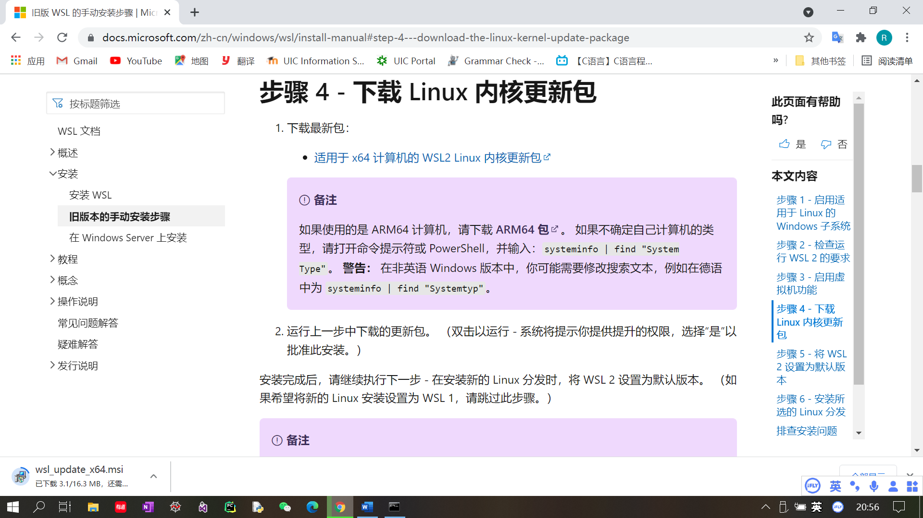

Download the kernel package corresponding to your computer. Click the downloaded .msi file once you finish downloading. And follow the document from the beginning.

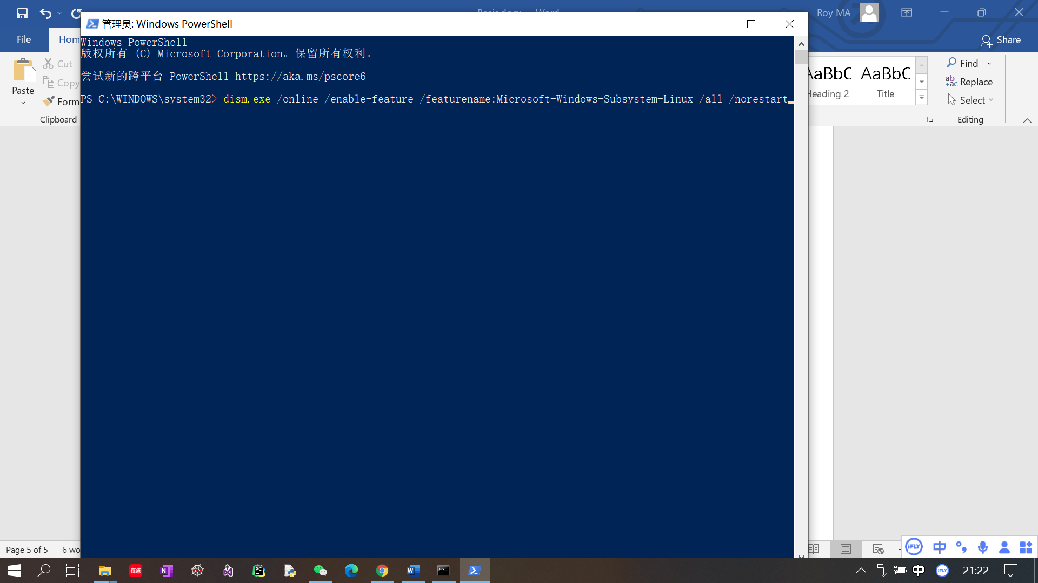

Open PowerShell in administrator mode. And type the above command.

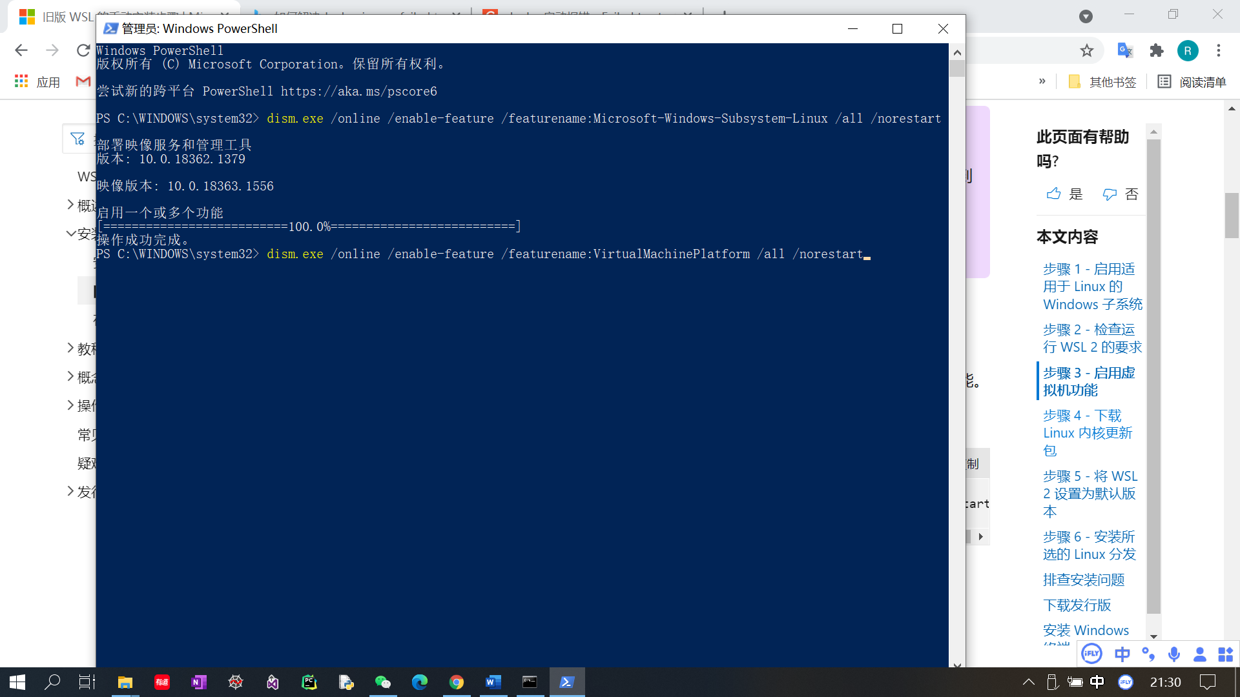

Type the above command. After you run such command, then restart your computer.

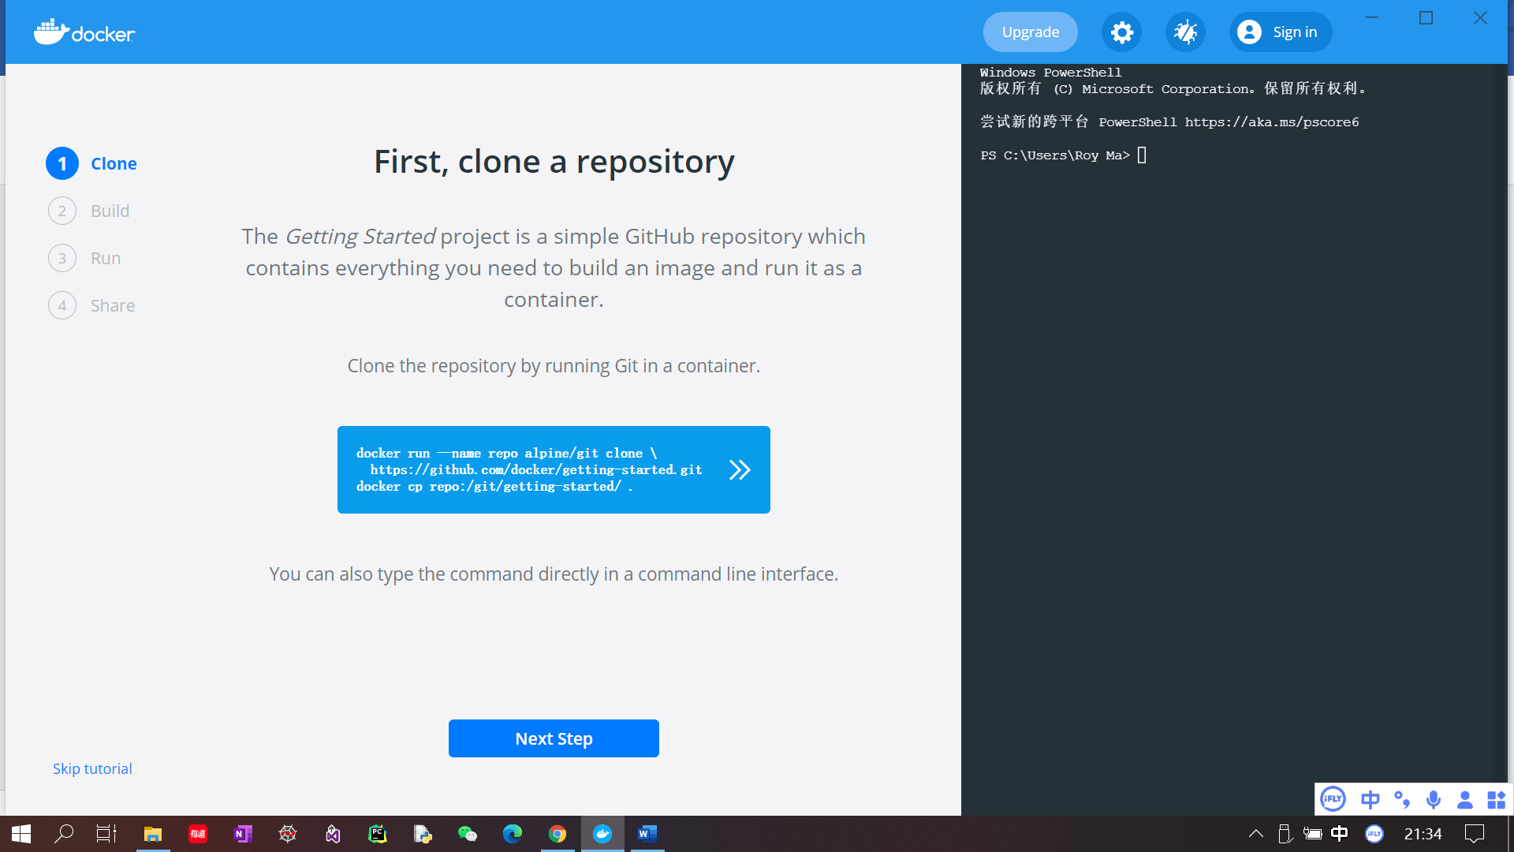

Once your computer restart, docker will be configured successfully. Click ‘Next step’ all the way.

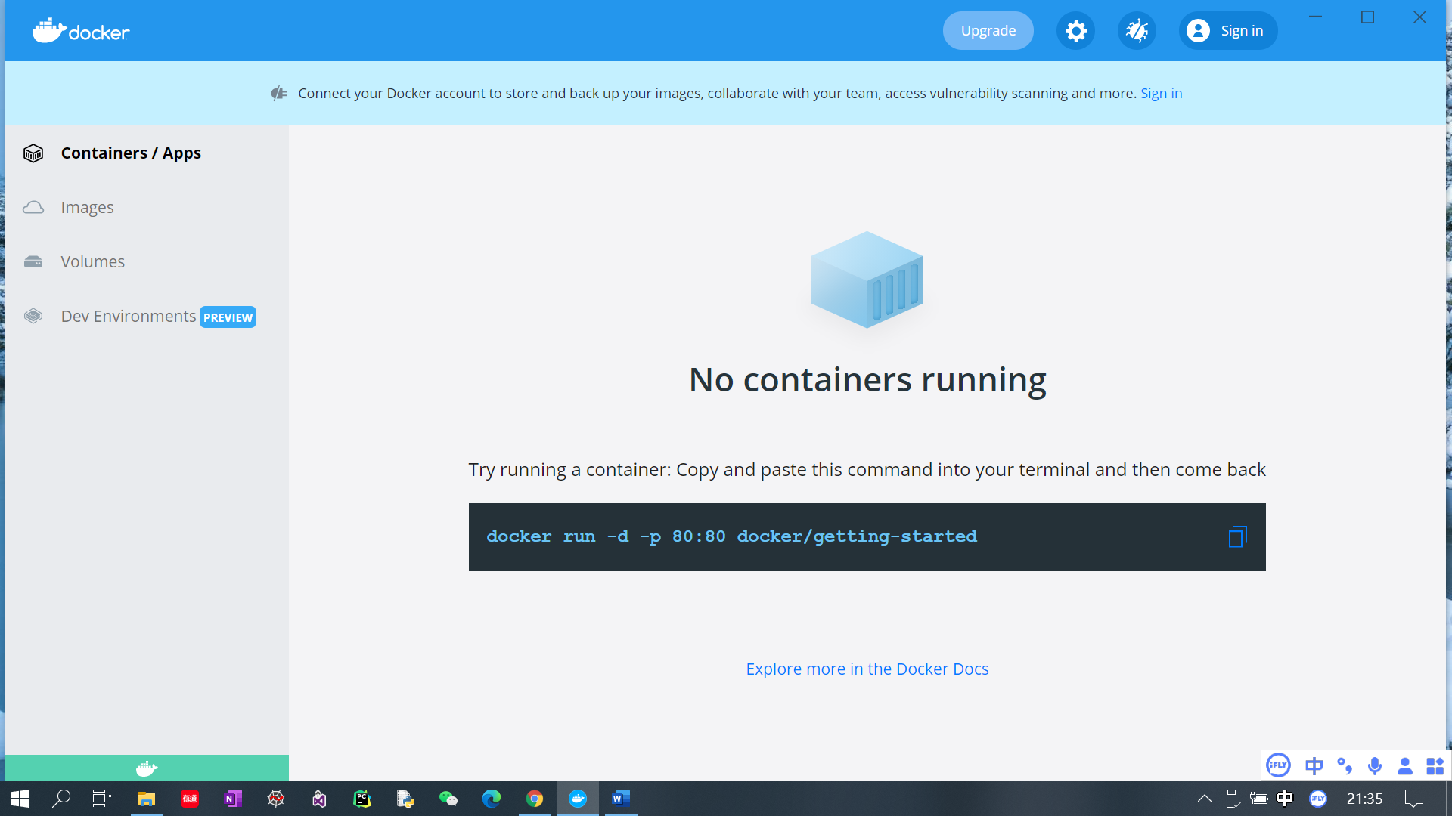

Finally, docker configuration done.